2nd Annual
Rotary Club of
TYLER
Sunrise

Prizes Galore...

HOLE in ONE!
Win a 2019 Cadillac XT4!!

at the exquisite
3 day/2 night for 4
$500 Nike Golf
Lajita Golf Resort Shopping Spree
L r
with Scope
4 Laser Rangefinde
Swing Caddie
SC200 Portable Launch Monitor

SEPT
9
2019
Hollytree Country Club
Registration includes lunch!

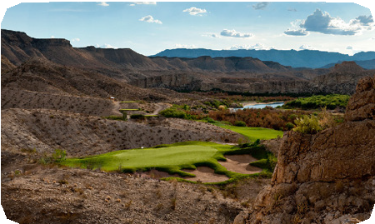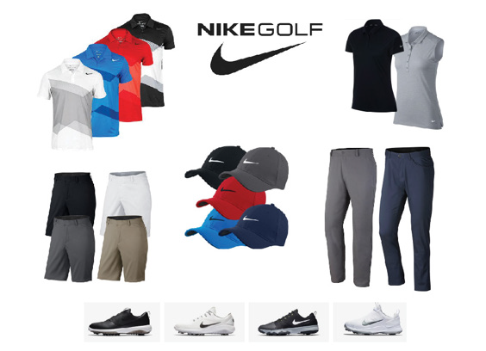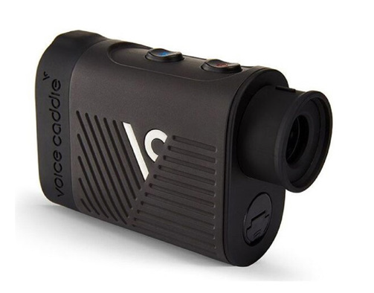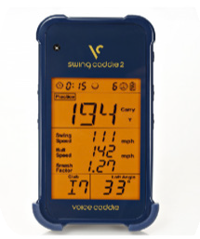
Teams of 4: $450 Includes lunch, green fees, 2 carts, practice balls
SPONSORSHIPS AVAILABLE!
For details: 903-393-6333 or email: tylersunriserotary@gmail.com
SIGN UP NOW! See reverse side for Entry Form
Benefitting Tyler Sunrise Rotary Club’s local and international service projects.

SPONSORSHIPS AVAILABLE
All sponsorships include business name/logo on signage and on all printed materials - and the opportunity to add branded items to our Player Grab Bags!
Longest Drive | $500
Par 3 CLosest to Pin | $500
goLf toweLs  Beverage Cart | $1,000  $1,500
includes 4 player entry and cart signage
tournament sPonsor $5,000

includes 4 player entry

includes 8 player entry and signage

******************************************************************************************************************************

ENTRY FORM

company/individual:
name: phone: email: type of sponsorship:

please make checks payable to: tyler sunrise rotary Foundation
po box 8383
tyler, tX 75711

THANK YOU FOR YOUR SUPPORT!

