THE DANIEL V. NEAL FOUNDATION OF THE
NORTH TEXAS PIONEERS
SPRING SWING
BENEFITING THE JOINT PLANO
POLICE OFFICER & FIRE FIGHTER MEMORIAL FUND

Ridgeview Ranch Golf Club
April 5th, 2019
SPONSORSHIP FORM
__________$1000 | Event Co-Host
__________$900 | Lunch Sponsor (2)
__________$500 | Breakfast Sponsor (2)
__________$500 | Entertainment Sponsor (1)
__________$300 | Beverage Cart Sponsor (2)
__________$150 | Hole Sign (36)
__________$150 | Awards Sponsor (2)

Company Name: ___________________________________________________________________
Address: __________________________________________________________________________
Contact Person and phone:___________________________________________________________
Email: ____________________________________________________________________________
Please consult with your tax advisor to determine if your donation is tax deductible in whole or in part.
Make Check payable to: Daniel V. Neal Memorial Foundation (EIN# 83-0801692))
Mail form and payment to arrive no later than March 5, 2019:
North Texas Pioneers Rotary Club
P.O. Box 861552
Plano, TX 75086

You may also purchase sponsorships at
www.NorthTexasPioneersRotary.com
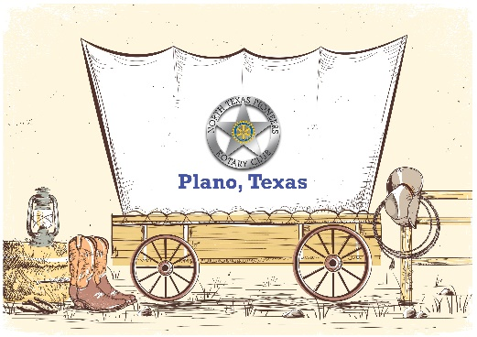
NTXPIONEERSROTARY@GMAIL.COM

