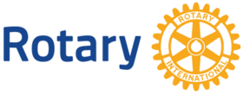
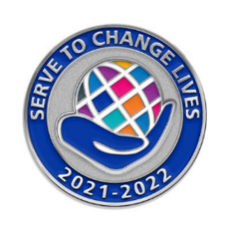
Celebrating Rotary Service
District Conference
September 24-26, 2021
Double Tree Westminster

Friday September 24th
- Past District Governors Dinner
6:00 Cocktail Hour
6:45 Dinner

Saturday September 25th
- End Polio Now Bike Ride
- Morning Service Project
- Young Professionals Summit ($25)
10:00-4:00
- Break Out Sessions for All Rotarians! (Free)
1:00 – 4:00 (Pick 2 to attend)
- Setting strategic direction for your club
- Fundraising concepts / ideas / strategies
- After the pandemic: Reengaging and achieving club vibrancy
- Dinner with Karl Mecklenburg, Former Denver Bronco Lineman ($75)
6:00 Cocktails
6:30 Dinner
7:15 Karl Mecklenburg inspires us

Sunday September 26th
- District 5470 Legislation Session and Awards Ceremony
9:00 am
- Rotary Day at the Rockies!
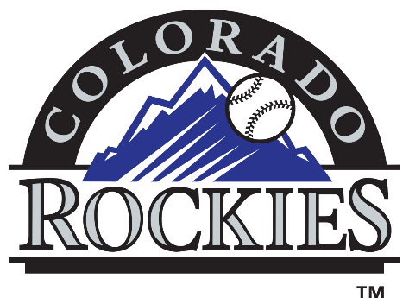
Ride the Light Rail to Coors Field
Colorado Rockies vs the San Francisco Giants
1:10 Game time

