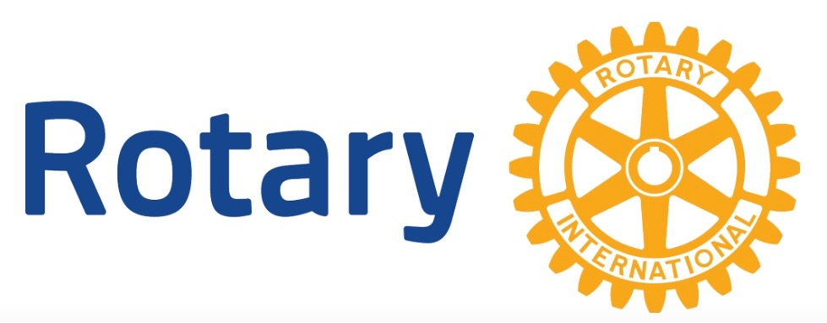
ROTARY CLUB OF YELLOWKNIFE
Rotary Executive Committee Meeting
12:00 pm, Wednesday – July 3rd, 2019
7th Floor, Northwest Tower Building

AGENDA

- Committee Business:
- Call to Order
- Approval of Agenda
- Approval of Minutes
- Matters arising from the Minutes:
- List of duties for the PR position - Robert
- Pancake Breakfast Expense Report to Darin – Wayne

- Committee Reports:
- President’s Report: Yanik D’Aigle
- President Elect: Wayne Guy
- Secretary’ Report: Chris Woods
- Vice-President’s Report: Celestino Oh
- Treasurer’s Report: John Hazenburg
- Membership: Norma Jarvis
- Club Administrator Report:
- Youth Services Report: Karen Wilford
- Rotary Foundation: Celestino Oh
- Public Relations Report:
- International Service Report: Chris Potyok
- Community Service Report:
- Sergeant at Arms: Lydia Bardak

- Old Business:
- AGM Financials FUP
- District Governor’s Visit
- Canada Day /Parade BBQ
- Lunch Options/ Copperhouse
- Canada Day Parade

- New Business:
- James O’Connor proposed new member
- Website Update
- Rotary Board Committees Update
- Email Regarding Bike Park
- Email Regarding Rotary Park Benches
- Budget 2019-2020

- Date and Time of Next Meeting:

- Adjournment:

