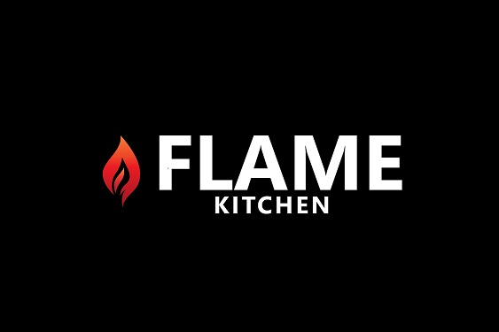
DINNER SET MENU - $50
APPETIZER
(Family style, Please choose any Three)

Tomato Bruschetta
Garlic, basil olive oil

Calamari Fritti
Fried Calamari, onion, lemon, spicy tomato sauce

Chicken Kebab
Chicken breast, marinated in yoghurt and spices, cooked in tandoor oven

Garlic cauliflower
Batter fried, sweet chilly garlic sauce, green onions
***************
SALAD/SOUP
Choose one

Chicken & potato dumpling soup
Celery, carrots, thyme

Caesar Salad
Romaine lettuce, parmesan cheese, croutons, crispy pancetta, caper berries

Chef's salad
Mix greens, cherry tomato, cucumber, onions, olives, lemon oregano vinaigrette
*************

MAIN COURSE
Served with Potato & vegetable

6oz Tenderloin or 10 oz New York steak
AAA Alberta beef, Grilled, Red wine or mushroom sauce

Grilled Salmon
Cherry tomato, garlic, olives, capers, lemon, white wine

Tandoori Chicken
Half chicken, mild spiced, marinated, cooked in tandoor oven, served with aromatic basmati rice

Penne primavera
Mixed vegetables, basil, tomato sauce

Aloo gobi
Potato, cauliflower, tomato, spices , served with basmati rice or Naan bread

DESSERT
Choose one

Tiramisu
Mascarpone cheese, lady finger cookies, coffee

Crème Brule
Vanilla custard, caramel

Gulab Jamun
Milk dumpling in flavored syrup

