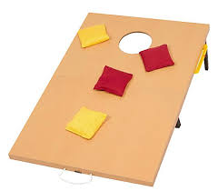

Bottle Hill Cob Lob
Bean Bag Toss Tournament
Saturday, July 21, 2018

Bean Bag Toss Board Sponsor Form

When: Saturday, July 21st, 2018 10 am – 3 pm
Where: St. Vincent’s Martyr Church
26 Green Village Road, Madison, NJ 07940
Cost: $100.00 to sponsor a Board. $150.00 for a Custom Set
Your Logo or message will be applied to the board
Artwork: Please provide Camera ready artwork (vector) for
Custom Logos. Please forward artwork, by July 10, 2018 to:
graphicaction.prosign@verizon.net

Complete the form below and send with your check to:
Madison Rotary Foundation P.O. Box 211, Madison, NJ 07940

Company:
______________________________________________________________________________
Contact:
______________________________________________________________________________ Address:
______________________________________________________________________________
City, State, Zip:
______________________________________________________________________________
Phone:
____________________________________________Amount of Check____________________
Email address:

Proceeds from this event go to Gift of Life, NJ Inc.
Providing resources to treat children with congenital heart defects in
developing countries

For more information, contact: Joe Smith (973) 865-4777
Ray Freaney (908) 803-4602

Make Check Payable to: Madison Rotary Foundation (501c3)

