MADISON ROTARY FOUNDATION
Bottle Hill Cob Lob
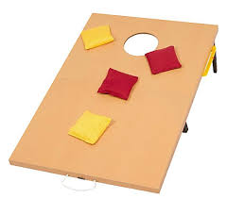
Bean Bag Toss Tournament
AKA CORNHOLE

Date: July 21, 2018

Place: St. Vincent’s Martyr Church
26 Green Village Road, Madison, NJ 07940

Time: 10 am – 3 pm
Cost: $25.00 per Player, 2 Players per Team

Guaranteed 3 Games, Round Robin Format

A Charity Event to raise Money for
Gift of Life, New Jersey

Providing resources to treat children with congenital heart defects in developing countries

Madison Rotary Foundation (501c3)

For more information, contact: Joe Smith (973) 865-4777
Ray Freaney (908) 803-4602

