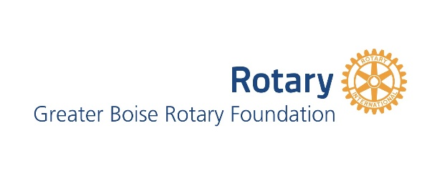

Greater Boise Rotary Foundation
Letter of Inquiry Form
This form must be submitted by midnight, October 10, 2019

Grant Request Information

Area of Interest The Arts
Education
Health and Social Services
Outdoor & Recreation
Enriching the Lives of Youth
Name of Organization:

Project Title:

Dollar Amount requesting:

Organization Information:

Federal Tax ID#:

Mailing Address:

City in Ada County: Zip:

Phone: Email:

Website:

Mission of Organization:

Contact Information:

Contact Person: Title:

Phone: Email:

Executive Director:

Project Details:

Criteria:
Our criteria apply to projects in Ada County.

Project Summary:
Be brief (50 words max), clear, and compelling.

Goals:
Describe the goals of your project. (75 words Max)

Meeting your goals:
How do you plan to meet your goals? (100 Words Max)

Project Budget:
Estimated Budget for this Project:

Submit your form to:
Nancy Chinn at nkchinn@gbrf.org

