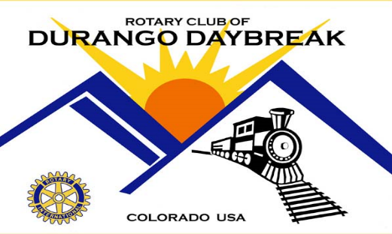

Durango Daybreak Rotary Club Chip Huntoon Memorial Food Drive to Benefit Manna
Saturday October 10th from 9am to 1pm at the LaPlata County Fairgrounds
Durango Daybreak Rotary club's Food Drive to Benefit Manna, is named in honor of Chip Huntoon, a former club member who passed away tragically and unexpectedly 6 years ago. Chip became a member of our club in 2010 and ran a firm that supplied lawncare, landscaping, handyman and snowplowing services to our area. He was an active member of our club and donated the space for our Club's Firewood Project out in the Animas Valley. Immediately after the accident, our club launched the Chip Huntoon Fund in Chip's honor. Family, friends and Rotarian's contributed monies to the fund whose goal is to work on "people projects" in concert with our Community Service Committee. The Manna organization was one of Chip's passions as a member of our club and the community at large.

Bring non-perishable food donations to LaPlata County Fairgrounds without getting out of your vehicle. If you prefer to make a monetary donation. Please make a check out to Manna.

Nonperishable food including:
- Fruit Cups or Canned fruit
- Canned Soup
- Canned Vegetables
- Ramen
- Mac & Cheese
- Granola Bars / Snack Bars
- Individual Oatmeal Packets and large Oatmeal
- Canned Spaghetti and Meatballs
- Canned Tuna/Turkey/ Chicken
- Individual Breakfast Cereal and Box Cereal
- Canned Chili
- Nuts
- Canned Vegetables
- Pasta
- Peanut Butter
- Jelly
- Mayo
- Bread
- Lunch Meat
- Vinegar

Additionally these items are also requested
- Body Wipes
- Deodorant
- Toothpaste and toothbrushes

