1st Annual Family BBQ at the Park

Come one, come all and let’s get our Families together and have a day of fun relaxing and catching up with Rotarians and their Families.

August 11, 2019 3PM-8PM
North Clackamas Park
5440 SE Kellogg Creek Drive
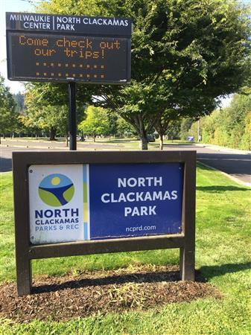
Activities include the following:
50/50 raffle
Door prizes
Volleyball
Corn hole
More fun
For more info and R.S.V.P. please contact:
Paul Geske 503-706-2586 paulgeske@hotmail.com OR
Maggie Sheldon 971-998-2063

