HOW TO DONATE OR JOIN OUR ALZHEIMER’S WALK TEAM
Go to act.alz.org
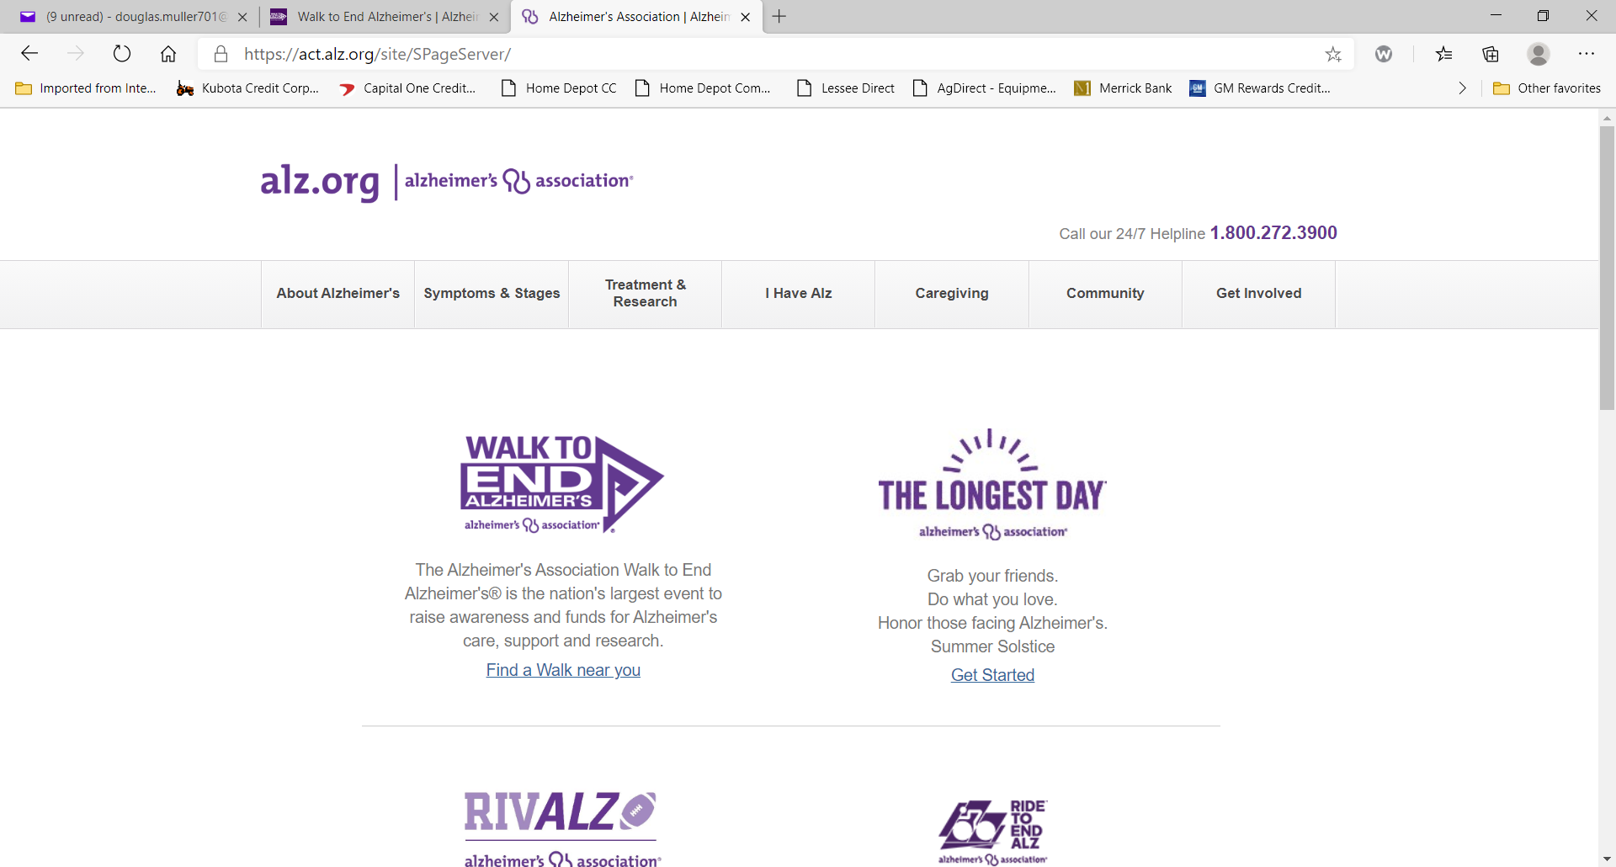

Click on TEAMS and type “Rotary Club of Monticello NY in the Search Box

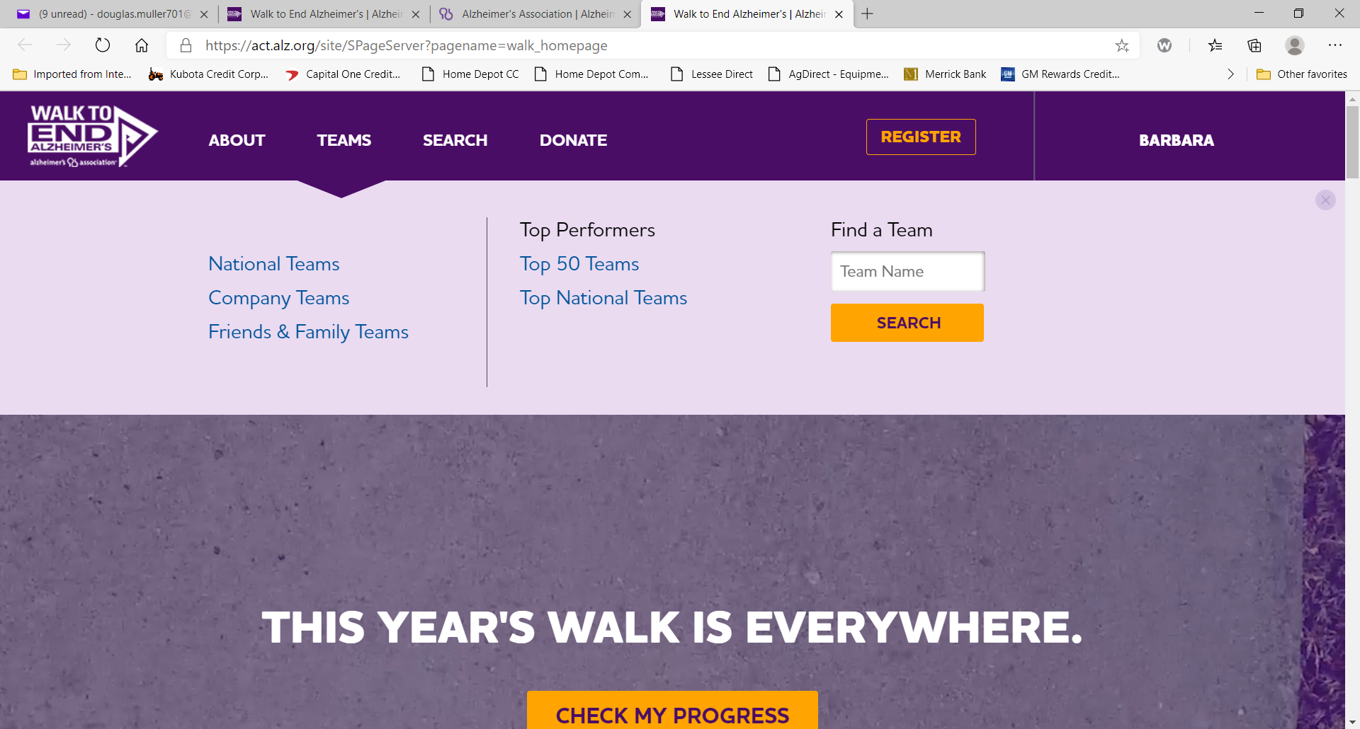
Click on Rotary Club of Monticello NY

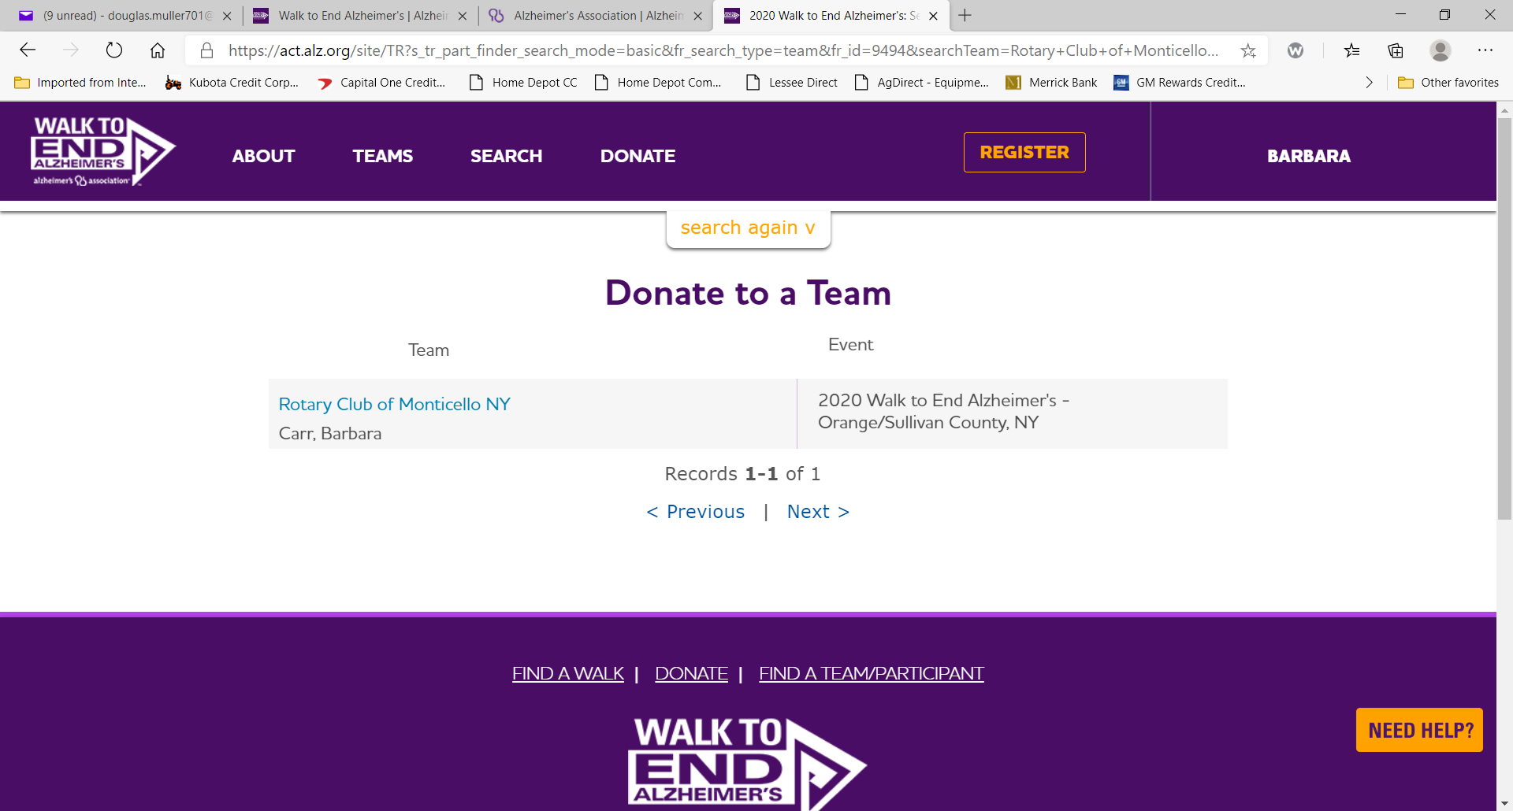

DONATE to the Team OR JOIN the Team!
Donations can be made by Credit/Debit Card or Pay Pal.

Team Members: Invite Friends to Donate/Share on Facebook

