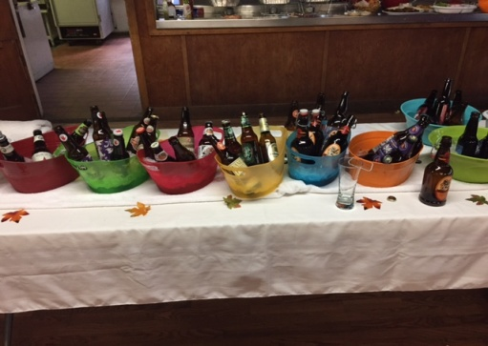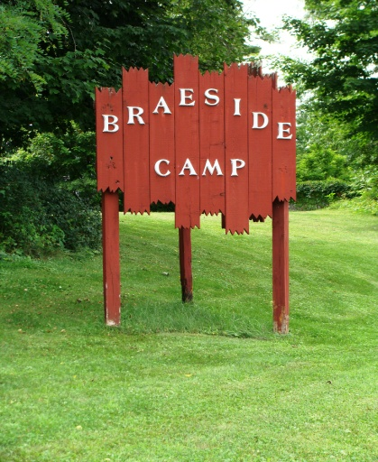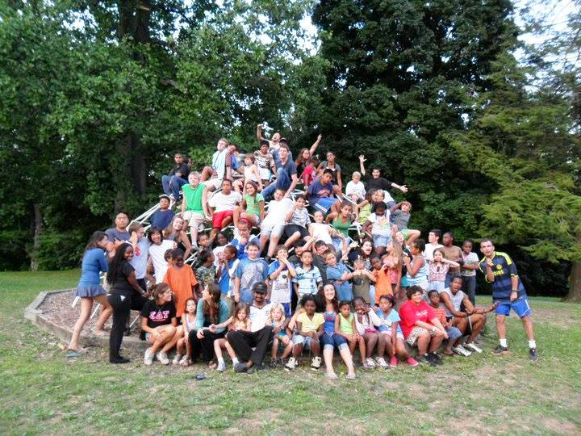
4th Annual Fall Fundraiser
Craft Beer, Wine & BBQ
To Benefit Braeside Camp
Saturday, October 21st, 2017 12:30pm to 5pm
Location: Braeside Camp 640 East Main Street, Middletown, NY 10940

Tickets: $20 (if purchased by 10/1/17, after $25)
$15-designated drivers (no alcohol)
Come join us on the grounds of Braeside Camp for a beautiful afternoon to enjoy a variety of local craft beers and wines including featured selections from Breweries & Wineries here in the Hudson Valley.
Your admission ticket is ALL INCUSIVE: beer & wine samplings, bottled water, soda and food.
This year, We’re Smokin’ !!!!
The Main Menu will include smoked chicken, ribs, beef brisket, pulled pork sliders, mac & cheese.
Other salads, homemade cornbread and snacks will also be available.
Corbett Hall will be open for all to enjoy a cozy afternoon with the fireplace going and music to enjoy. Weather permitting, lawn games will be available outside on the grounds of the camp or you can also sit outside under the pavilion.

All proceeds benefit Braeside Camp. For over 100 years, Braeside has provided economically disadvantaged and foster children of Orange County with a summer camp experience. Thank you for supporting Braeside Camp!!

Come out and enjoy the day with your friends for a great cause!

For Tickets, contact Brian McNamara, #845-978-9568 or email brianmcnamara@hvc.rr.com
(To purchase tickets via paypal.com: paypal.me/BraesideBBQ under special instructions, provide name & contact info)

