3rd Annual Art on the Fly
Sunday, July 1st, 6pm in Historic Downtown Livingston
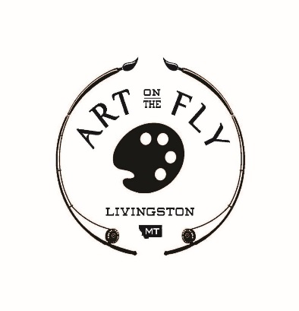
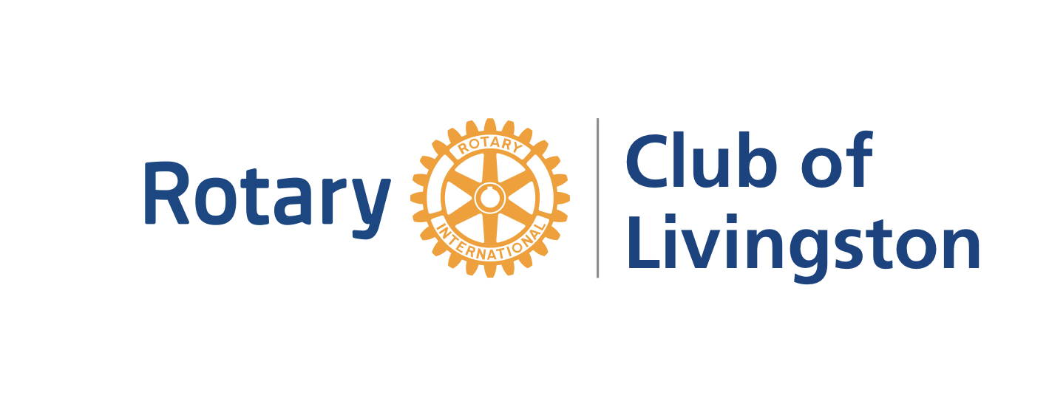

Business and Individual Sponsorship Levels

$2,000 “The Yellowstone” 10 Art on the Fly tickets, name on tables, tickets & promos, 2 Raffle Tickets
$1,500 “The Missouri” 8 Art on the Fly tickets, name on tables, tickets & promos, 2 Raffle Tickets
$1,000 “The Madison” 6 Art on the Fly tickets, name on tickets & promos
$750 “The Big Hole” 4 Art on the Fly tickets, name on tickets & promos
$500 “The Smith” 2 Art on the Fly tickets, name on promos
$250 “The Shields” 1 Art on Fly ticket, name on promos

Event Tickets-includes admission and BBQ dinner, complimentary drink token

$40 per person: 1 Ticket to Art on the Fly $75 per couple: 2 Tickets to Art on the Fly

Rotary Raffle: Custom made Parks Reese Trout Bench, $5000 value *only 150 tickets avail*
(Model bench is displayed in front of the Livingston Center for Art and Culture)

$50 per raffle ticket, winner will be announced at event on July 1st. Need not be present to win.

Can’t make the event? Help our club with your generous, tax deductible donation!
Other amount: $_____________

Business/Individual Name_____________________________________________________________________________
Address________________________________________________City__________________________Zip____________
Contact Name______________________________________________Phone___________________________________
Email______________________________________________________________________________________________
**************************************************************************************************
Sponsorship Name ____________________________ Sponsorship $ Total _________
# Event Tickets____ Event Ticket $ Total _________ # Raffle Tickets______ Raffle Ticket $ Total ________
Unfortunately I cannot attend, please accept my tax deductible donation $ Total____________
**************************************************************************************************
Please make your checks payable to Livingston Rotary Club: PO BOX 66 Livingston, MT 59047
Ticket orders received by June 21st, 2018 will be mailed to business address above. Orders received after June 21st will be held at gate.
Thank you for your support of Livingston Rotary Club! See you at Art on the Fly!

