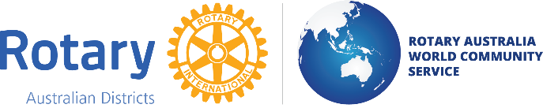

DONATIONS IN KIND
(An activity of Rotary Australia World Community Service Limited)
ACN: 003 444 264
NORTHERN REGION

Volunteer Information Form

Donations in Kind (DIK) Facility: 23-25 Mary Street, Kingston Qld 4114

RAWCS Donations in Kind Northern Region values the Health, Safety and Welfare of all our Volunteers.
As part of our Workplace Safety and Health Management System, we need to establish a register of volunteers to be used in case of a medical emergency or accident. All information supplied in this Form will be used for this purpose only.

Prior to working at the DIK Facility, all volunteers must provide the following information and complete formal Safety Induction Training by reading the Safety Induction Sheet and following the instructions of the DIK representative in charge on that day of attendance. Each Volunteer will only be required to complete this training once a year.

Volunteer’s Name ………………………………………….

Phone No. ……………………………. Mob No. .………………………….

Address: ………………………………………………………………………………………….

Volunteer’s Rotary Club (for Rotarians) ……………………………………………………

Name of Organisation (for Non-Rotarians) ………………………………………………………….

Contact Person details in Case of Emergency

Name …………………………………………

Phone No. …………………………… Mob. No ………..…………………

Do you hold a First Aid Certificate? Y/N Name of organization……………………….

Do you hold a forklift license? Y/N If yes License No …………………

Do you have a prior Medical Condition: Y/N Details: ………………………………………..

Signed:

Volunteer……………………………………………………... Date ………………………..

Note: This information will remain on the Register until such time as notification from the Volunteer of any change of the above details or a request from the Volunteer to remove his details from the Register.

