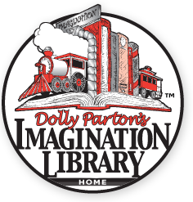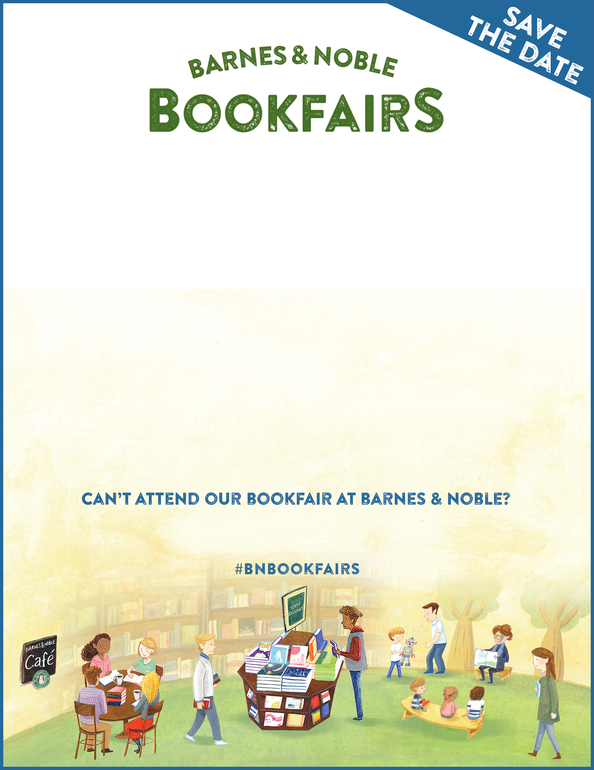

**To Support**

**on July 21st**

**at Barnes & Noble at 102 Dorset St.   
South Burlington, VT**

**Help support childhood literacy and our program to provide   
FREE books for hundreds of local children!**

Shop online at **BN.COM/bookfairs** to support us online from **7/21/18** to **7/26/18**

by entering Bookfair ID **12382941** at checkout.

A percentage of your Barnes & Noble purchases will benefit our reading program.   
More details online: burlingtonsunriserotary.com/Page/imagination-library