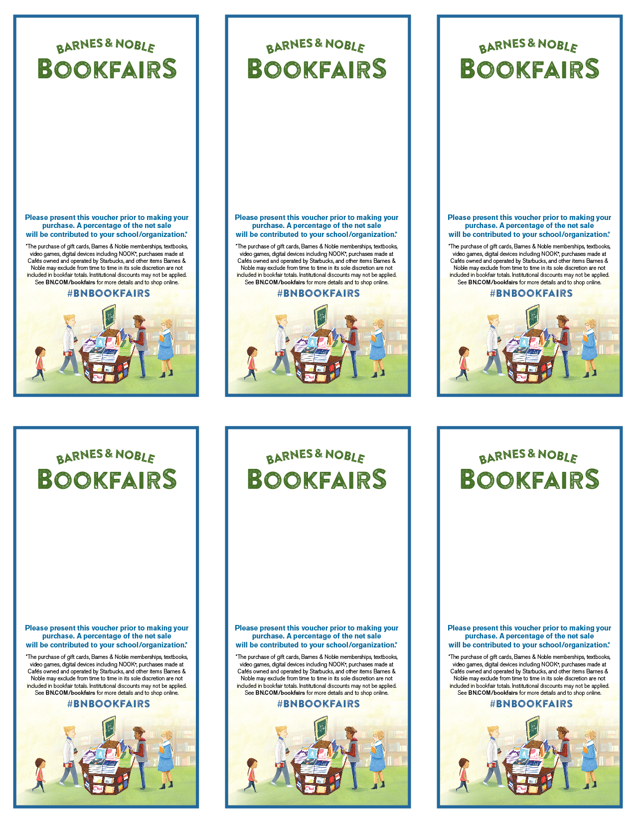

To support the

**Imagination Library**

**on July 21st**

**at Barnes & Noble,**

**102 Dorset St. South Burlington**

**Bookfair ID Number 12382941**

To support the

**Imagination Library**

**on July 21st**

**at Barnes & Noble,**

**102 Dorset St. South Burlington**

**Bookfair ID Number 12382941**

To support the

**Imagination Library**

**on July 21st**

**at Barnes & Noble,**

**102 Dorset St. South Burlington**

**Bookfair ID Number 12382941**

**on July 21st**

**at Barnes & Noble,**

**102 Dorset St. South Burlington**

**Bookfair ID Number 12382941**

To support the

**Imagination Library**

To support the

**Imagination Library**

**on July 21st**

**at Barnes & Noble,**

**102 Dorset St. South Burlington**

**Bookfair ID Number 12382941**

To support the

**Imagination Library**

**on July 21st**

**at Barnes & Noble,**

**102 Dorset St. South Burlington**

**Bookfair ID Number 12382941**

**Day, Date, Time**

**Barnes & Noble Location**

**Street Address, City Name**

**Bookfair ID Number**

**Day, Date, Time**

**Barnes & Noble Location**

**Street Address, City Name**

**Bookfair ID Number**

**Day, Date, Time**

**Barnes & Noble Location**

**Street Address, City Name**

**Bookfair ID Number**

**Day, Date, Time**

**Barnes & Noble Location**

**Street Address, City Name**

**Bookfair ID Number**

**Day, Date, Time**

**Barnes & Noble Location**

**Street Address, City Name**

**Bookfair ID Number**