**THE GREAT CHRISTMAS PRESENT STEAL**

**BRING A GIFT FOR UNDER $10.00**

**PUT IT UNDER THE TREE & TAKE A NUMBER**

**WHEN YOUR NUMBER IS CALLED PICK YOUR GIFT**

**IF YOU DON’T LIKE IT YOU CAN STEAL SOMEONE ELSES**

**BE CAREFUL THOUGH SOMEONE MAY STEAL IT BACK**

**BRING A WACKY GIFT OR A NICE ONE**

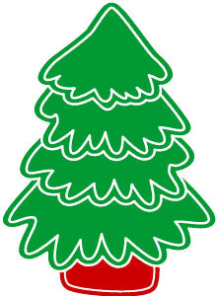

**19TH December 6:30 for 7:00 – finish at 8:00**

**Our last brekky until 2018**

**Wear your Christmas gear**

**Find a lot of cheer**

**And enjoy the rest of the Year**