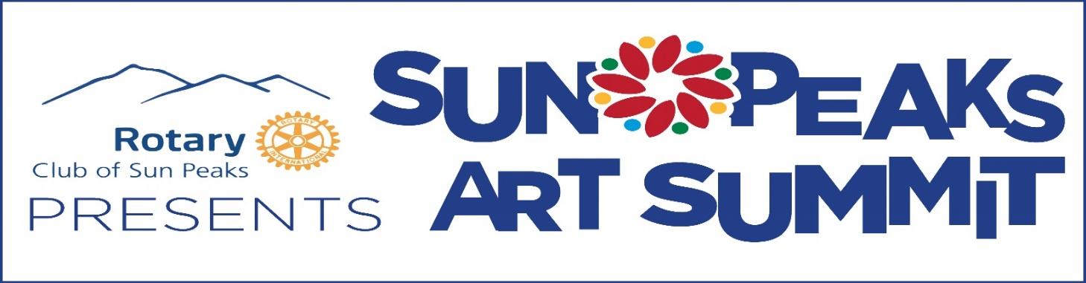
Vendor Application 2018
Submit online: Complete this form and email plus five photos to events@sunpeakstourism.com
Submit manually: Download this form and complete. Mail or drop off the form plus five photos on a flash drive or CD to Tourism Sun Peaks, 3250 Village Way, Sun Peaks, BC, V0E 5N0. (Office hours 8:30 am to 5:00 pm / Monday – Friday)
Early Bird application deadline: Friday, March 16, 2018 ($75 due after acceptance)
Final application deadline: Friday, June 1, 2018 ($100 due after acceptance)
Name: ________________________________________________________________
Type of Work: __________________________________________________________
Business Name (if applicable): __________________________________________
Mailing Address: _______________________________________________________________________
City: ________________________________ Province: _______ Postal Code: ____________________
Phone: _____________________________ Business or Cell Phone: _____________________________
Email: _________________________________________________________________
Website: ______________________________________________________________
If sharing a booth, name of proposed co-artist: _______________________________________________________________________
Co-artist must fill out their own application and submit an administration fee.

CATEGORY
What type of work(s) do you create?
__________________________________________________________________________________
Eg: 2D fine art (specify), 3D fine art (specify) jewellery, pottery/ceramics, clothing/accessories, woodwork, metalwork, glass, leather, fiber, henna, specialty foods, health and body products, other (please specify).
If you work in more than one type of art please provide percentages:
__________________________________________________________________________
For instance 75% paintings and 25% cards or 50% purses & 50 % earrings)

Our Selection Committee will be adjudicating your work based on your information provided below and photos of your work, so please answer each question below.
** Popular categories such as Jewellery, Henna and Pottery have a large number of entries and there are a limited number of spaces to be selected in each category. What makes your work stand out from the crowd?
MADE BY YOU:
Briefly describe the handmade process of your art form(s): 100 words max.
_______________________________________________________________________________________________________________________________________________________________________________________________________________________________________________________________________________________________________________________________________________________________________________________________________________________________________________________________________
List the materials used to create your work and where they are sourced:
__________________________________________________________________________________________________________________________________________________________________________
Is all of your work designed, made and packaged by you or is some reproduced or outsourced?
You Factory Locally Other _____________________________________
% Made by Me: __________ % Reproductions: ____________

JEWELLERY
(non-jeweller exhibitors may skip to PHOTO DOCUMENTATION)

The Sun Peaks Art Summit Committee will be selecting jewellers who are creating distinctive work with a strong hand-made component and will make sure that selected exhibitors specialize in different design styles or techniques.

_____________% of my work is created using beads and pendants that I have made myself.
_____________% of my work is created by assembling purchased beads and/or pendants
in a creative manner.
Note: Artists who simply string beads and add purchased pendants will not be accepted. In addition, artists who are accepted based upon creating their whole pieces will not be permitted to sell strung (purchased) beads and pendants (purchased). Purchased clasps, toggles, caps, connectors, etc. are permitted.

SPECIALTY FOODS & BODY PRODUCTS
(non-food & body product exhibitors may skip to PHOTO DOCUMANTATION)

Do you and/or your company hold a valid permit from a local, regional or provincial health authority?

YES NO, if no, why? ______________________________________________________

Please list items you intend to sell and price range:

_____________________________________________________________________________________

_____________________________________________________________________________________

_____________________________________________________________________________________

_____________________________________________________________________________________

_____________________________________________________________________________________

PHOTO DOCUMENTATION
You must send five images which exemplify your work. Clearly title each photo.
Photos must be in jpeg format (500 kb). Do not submit thumbnails or enlarged photos.
Hard copy photos will not be accepted.
Online application – email the photos with your online application.
Mail in / drop off application – photos must be on a flash drive or CD.
Be sure to show us true examples of what you plan to exhibit.
Our Selection Committee will be adjudicating your work with these photos. If your photos are not adequate for jurying you may be disqualified.
Please make sure to include photos of each category you are entering under. Artists may display/sell work only in the discipline(s) in which they are accepted. Work(s) for sale must be comparable to work shown in the photographs you submit.

Tourism Sun Peaks reserves the right to use photographs of all submitted artwork for promotional purposes.

ADMINISTRATION FEE
I am submitting my $10 Admin Fee by:
Cheque (mail in or drop off application only – payable to Tourism Sun Peaks) Visa Master Card Note: a 3% processing fee will be charged for credit card payment
Credit card information:
Name on card ________________________________________ Expiry date____________ (mo. / yr.)
Card #__________________________________________ CSC___________
Administration Fee (non-refundable) must be paid separately and is due with your application. Do not send the full registration fee. Registration fee is due only upon acceptance into the event. Acceptance notices will be emailed June 15, 2018.

Signature: ______________________________________________ Date: _________________________
By signing this document, you agree to accept all decisions of the Selection Committee as final and to abide by the policies of the Sun Peaks Art Summit organizers. You agree to not hold the Sun Peaks Art Summit organizers responsible for loss/theft/breakage to your work nor damage to yourself and/or to any of your assistants while participating in this event.

