Join us a fabulous Saturday lunch
To really welcome in Spring and the start of Summer
One 80 Restaurant, Copthorne Hotel Oriental Bay Wellington
‘Views to Dine for’
Saturday 15th October 12.30
Join us for a fabulous Indian themed, tapas/buffet style lunch. The wonderful chef at One 80 (and he is good – I can vouch for this) has graciously agreed to provide us with a similar, very successful combination he prepared a few years ago for Wellington on a Plate.
Includes:
Welcome drink
Glass of bubbles or Orange Juice
Thali
Chicken Lababdar| Paneer Lababdar| Kerala fried chicken| Saffron Jeera Basmati Rice
Served to the table to share
Black garlic Naan | Malaysian Roti| Pickle| Poppadum| Yoghurt Raita
To Finish
Macaron
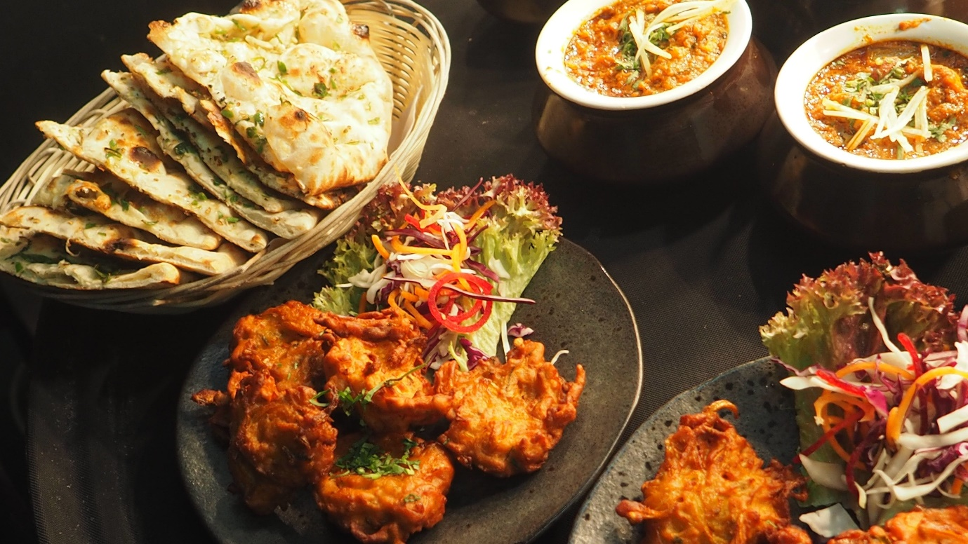
$45 per person. Join fellow Rotarians, friends and family. Guests welcome. Please RSVP by 12th October 2022. Any questions call Joy Durrant 021 620 557.

