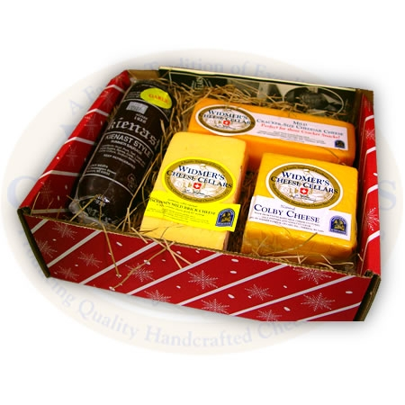
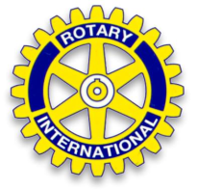
Say Cheese and Donate
to Support Madison East - Monona Rotary

Madison East - Monona Rotary Club welcomes your support to raise
money for local youth programs. These gift boxes make a great gift for
employees, friends, and neighbors. Gift boxes will be delivered in time for holiday gift giving.

Sales orders are due to your club contact no later than November 24th
Cheese Box  Descriptions | # of Orders Delivered To You  @ $35/Box | # of Direct Mail Orders **  @ $45/Box | Total Amount Due | Amount Paid
OPTION A: Assorted Gift Box  8 oz. each of: 1 year Sharp Cheddar, 2 year Aged Cheddar, Sharp Cheese Spread & 7 oz. Summer Sausage |  |  | $ | $
OPTION B: Aged Cheddar Sampler  8 oz. each of: 1 year Sharp Cheddar, 3 year Aged Cheddar, 5 year Aged Cheddar |  |  | $ | $
(payment via VENMO, check or cash) |  | Amount Due | $ | $

Delivery will be made after December 3rd
Buyer Name: |  | Phone:
Email Address:

**Names, Addresses and Cheese Options of Direct Mail Orders (please use additional sheets as needed)
Cheese Box  Option/#boxes | (A) | (B) | Name:
 | Address:

Cheese Box  Option/#boxes | (A) | (B) | Name:
 | Address:

Cheese Box  Option/#boxes | (A) | (B) | Name:
 | Address:

Contact Jim Oughton with questions at 608-347-2422 or joughton@charter.net

