Cycle Dindi 2018: Saturday April 7th - Registration Form
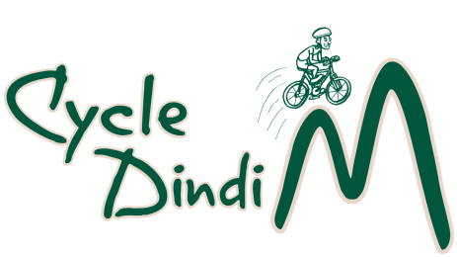

Name:
Address
Suburb/Town & Post Code
Mobile phone number
Email
Special Dietary Needs
Emergency Contact | Mob.
Please circle option
Options & Distances | Adult | Senior | Concession
Long Ride  Trawool-Yarck Return 109 Km  Trawool-Cathkin Return 97 Km  Yarck-Trawool Return 109 Km | $50 | $40 | $20
Short Ride  Yea-Cathkin Return 42 Km  Yea- Yarck Return 54 Km  Yarck –Yea Return 54 Km | $40 | $30 | $20

Concession applies to school aged participants
Seniors: Holders of Seniors’ cards
Under school age: free.

Payment Details (Tick Box)
Credit/Debit card payment at trybooking.com (cycledindi18)

Direct Deposit to Bendigo Bank BSB 633-000 Account Number 161857420.
Account Title: - Cycle Dindi
Please reference payment with name and ride option.
Registration by post to PO Box 149 Yea 3717 or email entry to: cycledindi18@gmail.com

Release and Indemnity Cycle Dindi 18

The Rotary Clubs of .Yea and Alexandra............................................................................................................................................ Inc. (“Rotary)

1. I, .................................................................................... of .......................................................................................
..............................................................................in the State of ............................................ am aware and acknowledge that
....Cycle Dindi 18............................................................involves inherent risks, including the risk of injury to life or death and damage to property and in undertaking such activities, I do so at my own risk.

2. I am also aware that it is a condition of participation in .............................................................................
..........Cycle Dindi 18............................................. that Rotary, its officers and employees, agents and volunteers are released by me from all liability howsoever arising from injury or damage to both property and person howsoever caused (whether fatal or otherwise) arising out of my participation in the Event whether or not such injury or damage is due to any negligent act, breach of duty, default and/or omission on the part of Rotary, its officers and employees, agents or volunteers.

3. I indemnify Rotary, its officers and employees, agents and volunteers against all loss, damage and expenses (including legal costs on a solicitor and own client basis) arising out of or in connection with any claims, actions, proceedings or demands of any kind arising directly or indirectly as a consequence of my participation in the Event.

4. I acknowledge and agree that my participation in the Event is as a consequence of my own free will and desire and that I have read and understood the above warning, release and indemnity.

5. I warrant that I am 18 years of age or older and am lawfully able to enter into this above release and indemnity or, in the event that I am a minor, I have the permission of my legal guardian to participate in the Event and that my legal guardian has agreed to adhere to the terms of the indemnity below.

Signed……………………….............................................................................

Dated this day of 2018

