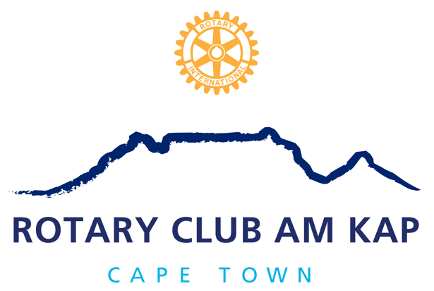

The members of the

Rotary Club am Kap

request the pleasure of your company at

the Induction Dinner of our

Incoming President, Heidi Brown-Koelble

on Thursday, 9th of July 2020 18:30h at
Zoom

Cost: R 100.00 per person

Including 2 Raffle Tickets

Please RSVP before 6th July 2020 to secretary@rcamkap.com

