BIO

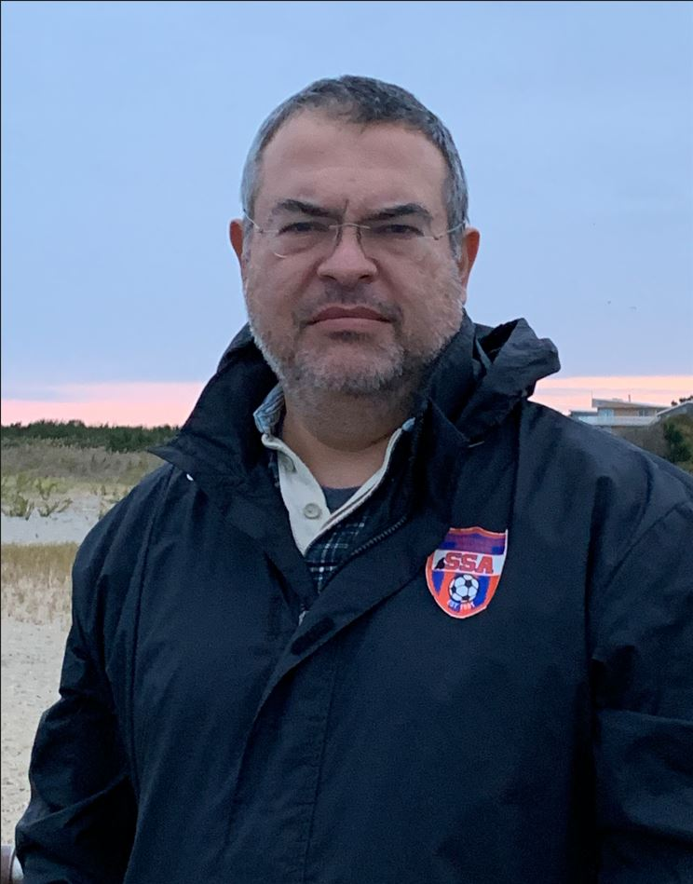
Rick Mavroudis represents Spartan Wall Security, a Cybersecurity services provider located in Huntingdon Valley.
He is a graduate of Temple University with a degree in Computer Science. He holds numerous certifications in Cybersecurity, Risk Analysis, IT Management, and Cloud Security.
Rick has experience working in IT and cybersecurity in several industries, including defense, retail, utilities, and banking.
Rick lives in Huntingdon Valley with his wife and children. When not working he enjoys coaching youth soccer and wrestling teams.

