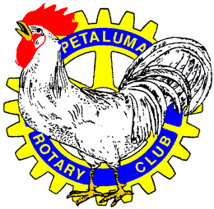

**Sponsorship Opportunities**

* **Golf Towel Sponsor - $1,500**
  + Golf towels with Your Logo distributed to all golfers at the beginning of the tournament.
* **Golf Divot Tool & Marker Sponsor $1,500**
  + Let everyone mark their ball with your logo. Divot Tool and Ball Marker set for all golfers.
* **Golf Ball Sponsor $1,250**
  + When we all tee it up, have your name all over the Tournament “ball of choice”.
* **19th Hole Sponsor - $1,000**
  + Banner Recognition at the “19th Hole” inside the Clubhouse where all the activities and dinner will be held.
* **Putting Green Sponsor - $750**
  + A sponsor sign that will definitely have great exposure at the Petaluma Golf & Country Club Putting Green that’s front and center upon arrival. You can’t miss this spot!
* **“Pit Stop” Sponsor - $500**
  + There is only ONE pit stop on this course where you can exclusively be seen by all golfers. The 5th Hole provides an opportunity to paste your Logo all over the “Pit Stop”. No one will forget who owned this spot!
* **Flag Sponsor - $250**
  + Your Name and Logo Recognition on the Hole Flag.
* **Hole Sponsor - $150**
  + Your Name and Logo on greenside sign.
* **Cart Sponsor - $50**
  + Your Name and Logo Recognition on All Carts